**Exercise 1 :** **Control Structures**

**Scenario 1:** The bank wants to apply a discount to loan interest rates for customers above 60 years old.

**Question:** Write a PL/SQL block that loops through all customers, checks their age, and if they are above 60, apply a 1% discount to their current loan interest rates.

**Program:**

BEGIN

FOR cust IN (SELECT CustomerID, DOB FROM Customers) LOOP

DECLARE

v_age NUMBER;

BEGIN

SELECT FLOOR(MONTHS_BETWEEN(SYSDATE, cust.DOB) / 12)

INTO v_age

FROM dual;

IF v_age > 60 THEN

UPDATE Loans

SET InterestRate = InterestRate - 1

WHERE CustomerID = cust.CustomerID;

DBMS_OUTPUT.PUT_LINE('Discount applied for Customer ID: ' || cust.CustomerID || ', Age: '

|| v_age);

END IF;

END;

END LOOP;

COMMIT;

END;

Output:

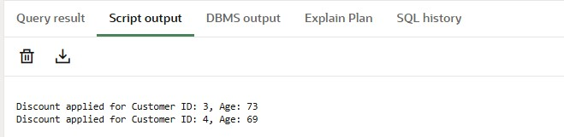

**Scenario 2:** A customer can be promoted to VIP status based on their balance.

**Question:** Write a PL/SQL block that iterates through all customers and sets a flag IsVIP to TRUE for those with a balance over $10,000.

First We need to Add the new column to the table **Customers**

ALTER TABLE Customers ADD IsVIP VARCHAR2(5);

**Program :**

BEGIN

FOR cust IN (SELECT CustomerID, Name, Balance FROM Customers) LOOP

IF cust.Balance > 10000 THEN

UPDATE Customers

SET IsVIP = 'TRUE'

WHERE CustomerID = cust.CustomerID;

DBMS_OUTPUT.PUT_LINE('Customer ' || cust.Name || ' (ID: ' || cust.CustomerID || ')

promoted to VIP.');

ELSE

UPDATE Customers

SET IsVIP = 'FALSE'

WHERE CustomerID = cust.CustomerID;

END IF;

END LOOP;

COMMIT;

END;

/

**Output :**

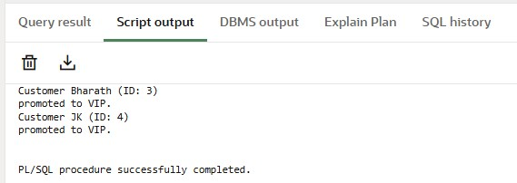

After executing the code the values in the table are;

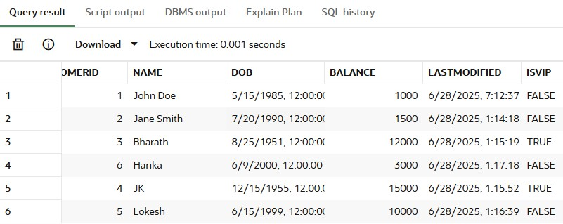

The customers with id 3 and 4 are marked as VIPs

**Scenario 3:** The bank wants to send reminders to customers whose loans are due within the next 30 days.

**Question:** Write a PL/SQL block that fetches all loans due in the next 30 days and prints a reminder message for each customer.

**Program:**

BEGIN

FOR loan_rec IN (

SELECT l.LoanID, l.CustomerID, l.EndDate, c.Name

FROM Loans l

JOIN Customers c ON l.CustomerID = c.CustomerID

WHERE l.EndDate BETWEEN SYSDATE AND SYSDATE + 30

) LOOP

DBMS_OUTPUT.PUT_LINE(

'Reminder: Loan ID ' || loan_rec.LoanID || ' for customer ' || loan_rec.Name ||

' is due on ' || TO_CHAR(loan_rec.EndDate, 'DD-MON-YYYY')

);

END LOOP;

END;

/

**Output :**

